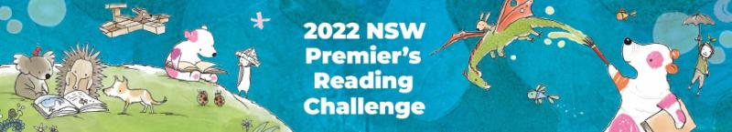

Premier’s Reading Challenge 2022
The PRC is now open! All students are invited to participate in the Challenge which runs from Monday, 28 February 2022 to Friday, 19 August 2022.
The Challenge aims to encourage a love of reading for leisure and pleasure in students, and to enable them to experience quality literature. It is not a competition but a challenge to each student to read, to read more and to read more widely. (PRC website)
To complete the challenge, students are required to read a combination of PRC books and personal choice books and enter them into their Student Reading Record located on their student portal. Students in K-2 can record books that have been read to them, as well as ones they can read themselves, whilst students in Year 3-6 must read the books by themselves.
The following table identifies the required reading requirements for each grade:
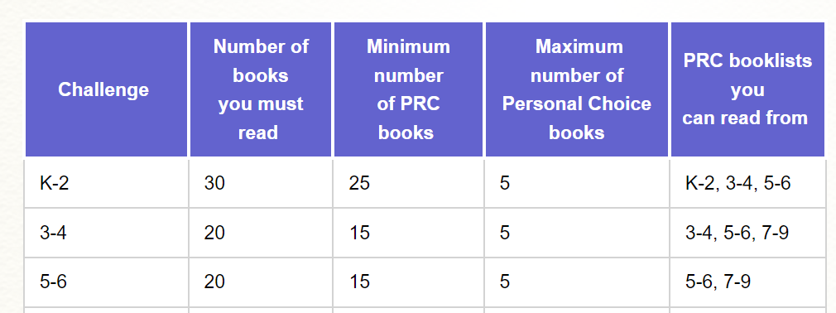

A full list of rules can be located at NSW Premier's Reading Challenge 2022 : Challenge Rules (det.nsw.edu.au)
Instructions on how to access the Student Reading Record and enter books your child has read will be shared in coming weeks or you can refer to the PRC website. PRC Student Experience : NSW Premier's Reading Challenge Support (freshdesk.com)
If you have any questions, please direct them to Mrs Chapman our PRC Coordinator and Teacher Librarian.

