

**Enrolment Procedure**

*This procedure was developed in reference to the* [*NSW Department of Education General Enrolment Procedures*](https://education.nsw.gov.au/policy-library/associated-documents/pd-2002-0006-01.pdf) *(Policy Document 2002/0006/01/v1.0.0).*

*This procedure is located on Wallsend South Public School’s website within the* ***Enrolment at WSPS*** *tab.*

Wallsend South Public School website: <https://wallsends-p.schools.nsw.gov.au/>

**Local Enrolment Process:**

Parents/carers may enrol their child in Kindergarten at the beginning of the school year if the child turns 5 years of age on or before 31 July in that year. The *Education Act 1990* mandates that all children must be in compulsory schooling by 6 years of age.

Parents/carers complete an online enrolment application which is available from NSW Department of Education. It can be accessed through Wallsend South Public School’s website within the Enrolment tab.

Parents/carers may seek to enrol their child at Wallsend South Public School, however *enrolment is only guaranteed for those living within the school’s local intake area*. Please refer to Appendix 1 of this document or Wallsend South Public School website to view our local intake area.

To confirm a child’s eligibility to enrol, proof of address is required. Please refer to the *100 point residential check table below for proof required*. This documentation must be sighted at the front office and verified.

|  |  |
| --- | --- |
| **Document showing the full name of the child’s parent** | **Point** |
| 1. Only one of (i.e. no additional points for additional documents)    1. Council rates notice    2. Lease agreement through a registered real estate agent for a period of at least 6 months or rental board bond receipt    3. Exchanged contract of sale with settlement to occur within the applicable school year | 40 each |
| 1. Any of the following:    1. Private rental agreement for a period of at least 6 months    2. Centrelink payment statement showing home address    3. Electoral roll statement | 20 each |
| 1. Any of the following:    1. Electricity or gas bill showing the service address*    2. Water bill showing the service address*    3. Telephone or internet bill showing the service address?    4. Drivers licence or government issued ID showing home address?    5. Home building or home contents insurance showing the service address    6. Motor vehicle registration or compulsory third party insurance policy showing home address    7. Statutory declaration stating the child’s residential address, how long they have lived there, and any supporting information or documentation of this | 10 each |

* Up to 3 months old

**Non-local Enrolment Process:**

Parents/carers living outside of Wallsend South Public School’s local intake area may apply to enrol their child although this is subject to Wallsend South’s student enrolment cap (capacity).

A number of local enrolment places (buffer) are reserved for local area students arriving throughout the year. The buffer number is based on historical data and is reviewed annually so is subject to change. ***At Wallsend South the enrolment cap is 557 with an additional buffer of 15 places for local enrolments.*** If enrolment reaches 557 students, Wallsend South Public School is unable to enrol non-local students.

Where non-local enrolment applications exceed available places, an enrolment panel will be formed to consider non-local criteria addressed in the online enrolment form. Please contact the school office for application closing dates.

**Non-local enrolment application**

From 2023, the school accepts online non-local applications as part of the online enrolment process. *Your enrolment application must address the following criteria as this is the only information that will be considered.*

Criteria – ranked in order of priority

1 Siblings already enrolled at the school.

2 Structure and organisation of the school – the school considers cohort numbers in relation to class size and overall cohort numbers.

3 Safety and supervision of the student before and after school.

4 Compassionate circumstances.

Priority will be given to siblings of currently enrolled students although this does not guarantee an enrolment offer.

Additional and supporting documentation for your child (that further supports consideration of the priority areas) can be provided to school prior to the application closing date.

**Enrolment Panel**

The enrolment panel consists of; an executive staff member, one teacher nominated by the principal and one parent representative nominated by the school’s parent organisation. The principal is not on the panel.

The panel *only considers the information and supporting documentation presented in the enrolment form or any additional documentation provided before the closing date*. Requests to include further information after the panel has convened will not be accepted or considered.

The school will inform parents/carers of the outcome of their application in a timely manner.

**Waiting List**

A waiting list may be created for non-local students who are not offered enrolment. The waiting list is determined by the panel. Parents are advised in writing if their child is on the waiting list and of their position on the list.

**Appeals**

Unsuccessful applicants may lodge an appeal with the principal. The appeal must be made in writing to the principal within 10 days of being informed, stating the grounds for the appeal. The principal determines whether the panel has applied the stated criteria equitably and makes a determination. Parents will be advised of the outcome in writing.

Kelly Deakin

Principal

Appendix 1 – WSPS Local Intake Area

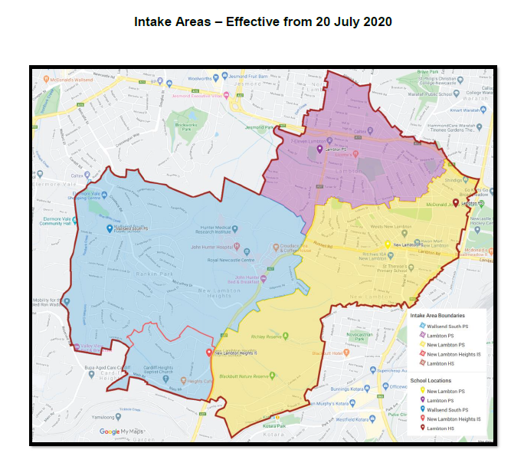

Wallsend South Public School intake area is highlighted in blue in the above map.

Please use the **School Finder** app which can be found on our website or on the NSW Department of Education website to search for your local school.